Use of the Riparian Rapid Assessment Method within
the San Lorenzo Watershed; 2015-2020

Alex Johanson & Maya Vavra

Central Coast Wetlands Group @ Moss Landing Marine Labs

County of Santa Cruz – Water Resources Program

Watershed Stewards Program

23-March-2021

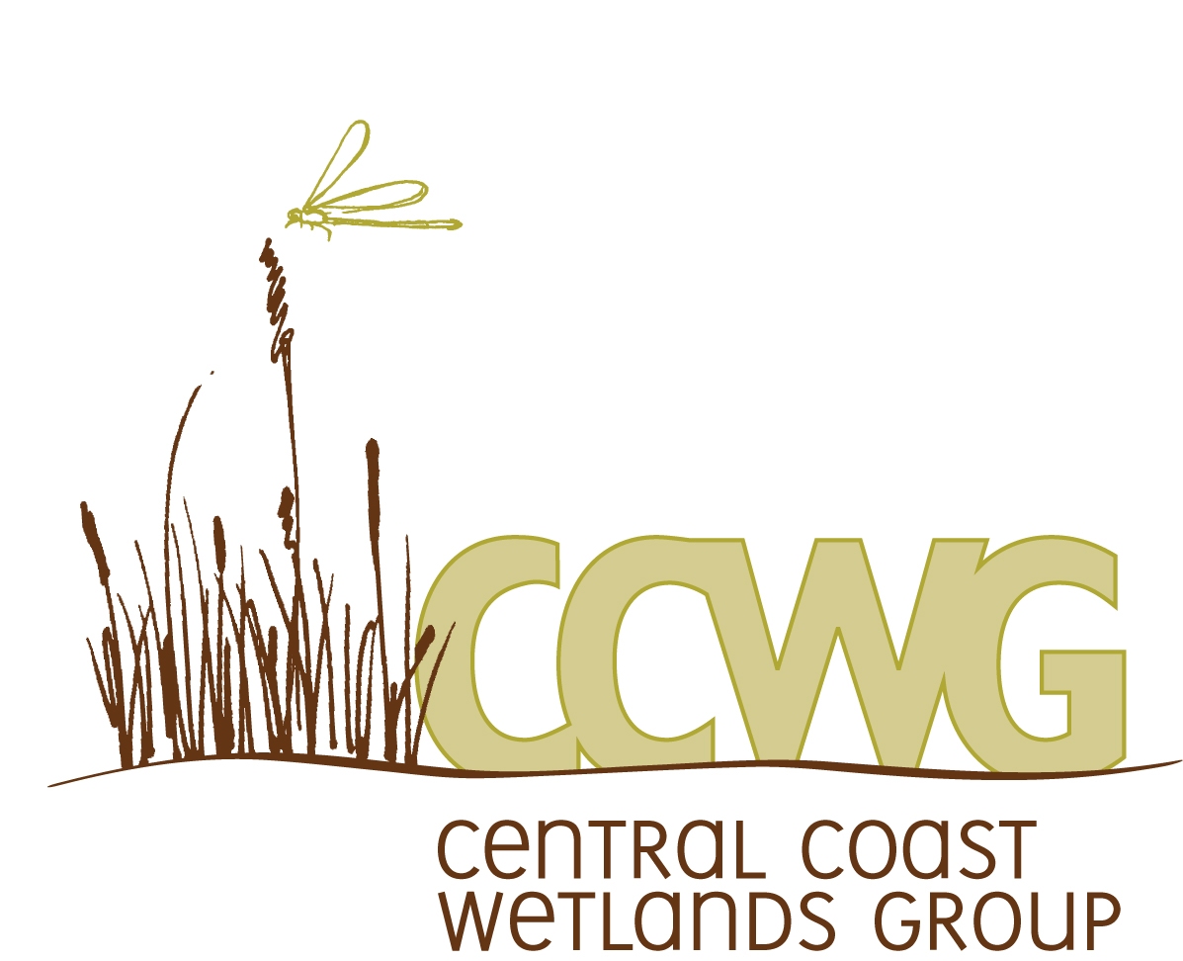

Abstract
The primary purpose of this study is to document current riparian conditions across the San Lorenzo River Watershed that can be used to develop and implement riparian protection or enhancement projects, consistent with the goals of the San Lorenzo River Riparian Conservation Program (2018). The San Lorenzo River Watershed is identified by local, state and federal agencies as a priority area for conservation and restoration due to the historic presence of coho salmon (Oncorhynchus kisutch) and current presence of steelhead (Oncorhynchus mykiss). The watershed provides drinking water and groundwater basin recharge to local communities.
To assess riparian conditions, this study uses the Riparian Rapid Assessment Method (RipRAM), a monitoring tool that can be used to quickly evaluate the overall health of a selected riparian area. RipRAM was developed to create a standardized assessment method that researchers, land managers, and restoration practitioners across the State of California can use to assess the health of a diverse array of stream types and their associated riparian habitats.
Between 2015-2020, a total of 130 sites in the watershed have been assessed with RipRAM, using a series of eight Metrics that measure habitat quality and generate an overall Index Score rating of 0-100 for each individual assessment site. This study also provides an analysis of how the RipRAM scores vary across different levels of urban development, identified as Extent of Development and determined using Google Earth’s FEMA Floodplain Layer to identify the percentage of the FEMA 100-Year floodplain that had been developed. Of the total 130 sites, 32 assessment sites were ranked as Very Low Extent of Development, 31 were Low, 23 were Medium, 17 were High, and 27 were Very High. As expected, as level of development increased, RipRAM Index Scores decreased. While Extent of Development is co-associated with Metric 5, this analysis was completed to demonstrate how development within the 100-year flood plain is a key aspect that affects riparian assessment scores.
For each assessment site, any metric scoring less than or equal to 50 was considered a key driver to the low score. At the watershed level, 63/130 (48%) of sites scored below 50 for Metric 3 (Riparian Cover Quality), and 64/130 (49%) sites scored below 50 for Metric 5 (Riparian Vegetation Width). Since Metric 3 is significantly reduced by low numbers of codominant native tree and shrub species as well as the presence of invasive plant communities, restoration projects should focus on increasing native plant diversity and removing invasive species in urban and residential areas. Metric 5 is affected by the amount of development reducing the width of riparian vegetation within the historic 100-year floodplain, so restoration efforts should focus on removing any non-essential man-made structures along creek edges and focus on increasing the presence of native vegetation between buildings and in areas where the riparian zone width could be extended fully to the edge of the 100-year floodplain.

Keywords: RipRAM, habitat condition, habitat fitness, quality, riparian, salmonid

Introduction

This study provides a baseline on the current condition of riparian corridors in the San Lorenzo River watershed, using the recently developed Riparian Rapid Assessment Method (RipRAM). RipRAM is a tool utilized by trained practitioners to quickly summarize the overall health and fitness of a designated riparian area.
Riparian habitat areas are defined as the transitional zone between terrestrial and aquatic ecosystems where surface and subsurface hydrology connect water bodies with their adjacent uplands. Riparian areas can border perennial, intermittent, and ephemeral streams, lakes, and estuarine-marine shorelines (National Resource Council, 2002). The San Lorenzo Watershed contains approximately 281 miles of riparian habitat (SLRRCP, 2018).
Riparian habitat provides important ecosystem services, including protecting water quality for community drinking water supplies, groundwater recharge, recreation, and bank stability that protects buildings and infrastructure such as roads and bridges. Riparian areas strongly influence the quality of aquatic habitat that supports native fish and wildlife including steelhead (Oncorhynchus mykiss) and coho salmon (Oncorhynchus kisutch). Protection and restoration of riparian areas are identified in recovery plans for both steelhead and coho salmon. Due to their linear form, riparian areas provide wildlife corridors, critical to the movement of wildlife, especially in developed areas.
In 1977, the County of Santa Cruz approved the Riparian Corridor and Wetlands Protection Ordinance to protect riparian habitat from human development. On perennial streams, the ordinance defines a protected area that extends 50 feet from the mean high-water mark or to the edge of the riparian woodland. While this ordinance has been effective at protecting riparian areas from new development, it has not addressed impacts from development that already existed in 1977. In 2015, the County of Santa Cruz initiated an effort to evaluate local riparian conditions, especially within areas developed prior to 1977. The County partnered with the Central Coast Wetlands Group (CCWG), who were working on the development of a riparian assessment method. By 2018, multiple organizations, including the City of Santa Cruz, County of Santa Cruz, Resource Conservation District of Santa Cruz County (RCD), and CCWG, completed the San Lorenzo River Riparian Conservation Program (SLRRCP). This effort has a primary goal to “protect and restore riparian corridors for fish and wildlife, groundwater recharge, stream bank protection, and water quality” (SLRRCP, 2018). The SLRRCP identified an assessment of current riparian conditions as a priority next step.
RipRAM is based on the California Rapid Assessment Method for Wetlands (CRAM), modified to riparian systems using a focused series of eight metrics that, when averaged, produces a total Index Score that can be used to quantitatively understand the fitness or health of a designated riparian area. These metrics focus on variables such as the presence/absence of invasive plant species, the age structure and regeneration status of various riparian tree species, and the level of development at the assessment site. RipRAM assessments define the stressors of a riparian area that reduce their fitness.
The purpose of this report is to summarize the results of those assessments and to provide information to support the development of an effective strategy for protecting and restoring riparian corridors in the San Lorenzo River Watershed. Study partners included the Central Coast Wetlands Group, the County of Santa Cruz, and the Watershed Stewards Program (WSP). The Watershed Stewards Program, administered by the California Conservation Corps in partnership with AmeriCorps, is a 10.5-month national service program whose mission is to conserve, restore, and enhance anadromous watersheds for future generations by linking education with high quality scientific practices. Two WSP Members have been placed at CCWG each term from 2015-2020 and each year collected data for this study.

Methods

Conducting Riparian Rapid Assessment Method for California (Version 1.6)
Site Selection:
Most RipRAM assessment locations (“assessment areas”) in the San Lorenzo watershed were located at bridges or stream-crossings that provided an unrestricted view of the assessment area. When possible, the assessment teams walked the entire assessment area, but if this was not possible due to steep banks or private property, the assessment was conducted from the stream crossing. By choosing sites with a broad view upstream, surveyors are given a more holistic perspective of the assessment area and are afforded the insight into whether or not and how far the Index Score can be extended further up the waterway. Once the assessment is completed, Google Earth is used to determine how far upstream a score can be projected. Score projections end when any significant change to riparian conditions occur, such as a junction with another stream that alters sediment supply or stream flow, or anthropogenic alterations such as changes to channel morphology or riparian vegetation (vegetation removal, agriculture, or development).

Establishing the Assessment Area (“AA”):
Establishing a proper AA is a critical step in correctly performing a rapid assessment using RipRAM. While it can be difficult to identify the extent of a riparian area, surveyors used evidence of fluvial terraces, the presence of riparian vegetation, and signs of large floods as markers of the riparian corridor’s width. The riparian area consisted of all the space from the edge of the wetted channel to the high end of the 100-year floodplain and stopped at any man-made structures that severely disconnected the riparian area from the floodplain or upland habitat. The AA extended upstream from the assessment point for a distance equal to 10x the average bankfull width, up to 200 meters, and did not extend past any stream confluence that would alter sediment supply, flow, or channel width. Prior to arriving at the AA, aerial photographs were assembled using Google Earth to help identify the edge of the 100-year floodplain and the extent to which the assessment can be projected upstream of the assessment area. FEMA floodplain maps (where available) provided helpful information on the extent of the 100-year floodplain.

Conducting the Assessment:
Assessments were conducted by at least two practitioners trained in the RipRAM method and took approximately 60 minutes to complete. The 130 sites were assessed by five teams of Watershed Stewards Program Members over the course of five years. Practitioners followed the guidelines in the RipRAM manual to assess and score each of the following metrics:
- Total Riparian Cover
- Vegetation Cover Structure
- Vegetation Cover Quality
- Age Diversity and Natural Regeneration of Woody Vegetation
- Riparian Vegetation Width
- Riparian Substratum Condition and Vertical Connectivity
- Macroinvertebrate Habitat Patch Richness
- Anthropogenic Alterations to Channel Morphology
Refer to Table 1 for a description of each metric. Each metric has modifying variables that either increase the score due to healthy conditions or decrease the score due to negative attributes. Once all metrics were evaluated, an Index Score was generated based on the average of all eight metric scores.

Table 1. RipRAM Metrics. This table provides the basic descriptions of each of the RipRAM metrics that are used to generate the final Index Score for an assessment site.
RipRAM Metric name | Description
Metric 1:  Total Riparian Cover | Total perennial vegetation cover in riparian and channel areas, excluding the low-flow channel. Modifiers for connectivity to the adjacent uplands.
Metric 2:  Vegetation Cover Structure | Tree cover in riparian and channel areas, excluding the low-flow channel. Modifiers for shrubs and helophytes (rushes, sedges, etc.).
Metric 3:  Vegetation Cover Quality | Native tree and shrub species, with adjustments for different channel forms. Modifiers for man-made structures, non-native plants, and trash.
Metric 4:  Age Diversity and  Natural Regeneration | Prevalence and distribution of age classes of woody species (sprouts, saplings, adults, dead standing trees, and dead fallen trees).
Metric 5:  Riparian Vegetation Width | Width of riparian vegetation relative to bankfull width, with adjustments for confined or non-confined valleys.
Metric 6:  Riparian Soil Condition  and Permeability | Soil cover by vegetative litter or herbaceous plants, with score reductions for bare zones, compaction, or impervious surfaces.
Metric 7: Macroinvertebrate  Habitat Patch Richness | Physical structures that promote habitat diversity: presence of cobble/boulder, coarse gravel, sands and fines, leaf packs, fine woody debris, large woody debris, overhanging vegetation, and aquatic vegetation. Modifiers for large amounts of sands and fines, helophyte cover, and algae mats.
Metric 8: Anthropogenic  Alterations to Channel  Morphology | Hydromodification causing incision or aggradation, with modifiers for hardened structures, severe erosion, and disconnection from the floodplain. Streambank hardening and straightening.

Data Assessment and Analysis
Dividing the San Lorenzo Watershed:
For this study, the San Lorenzo Watershed was divided into four groupings: San Lorenzo Mainstem, San Lorenzo Tributaries, Branciforte Creek, and Zayante Creek. Special attention has been given to Branciforte Creek and Zayante Creek due to their consistent high juvenile steelhead densities and their importance to coho and steelhead recovery. The Zayante Creek subwatershed includes Bean Creek, Mackenzie Creek, Lompico Creek, and Ruins Creek. The Branciforte Creek subwatershed includes Carbonera Creek, Crystal Creek, and Granite Creek. The San Lorenzo Mainstem only includes sites that fall along the mainstem, and the remaining group, designated as the San Lorenzo Tributaries, includes Bear Creek, Boulder Creek, Deer Creek, Fall Creek, Jamison Creek, Kings Creek, Love Creek, Two Bar Creek, and Newell Creek.

Analyzing Index Scores:
Once all the scores were entered, the data were organized into the four groupings (San Lorenzo Mainstem, San Lorenzo Tributaries, Branciforte Creek, and Zayante Creek). A map was created using GIS to show the Index Scores of each assessment site throughout the San Lorenzo Watershed (Figure 1), as well as how far that score was projected upstream. For each assessment site in the watershed, and again within each of the four groupings, all values for each metric were entered into a spreadsheet and displayed in plots to highlight the overall variance between sites and their respective scores. Each assessment site was then divided into scoring categories and a histogram was created to show the distribution of scores for both the entire watershed and in each grouping. The score categories are as follows: 0-20, 21-40, 41-60, 61-80, and 81-100 (Figure 3 and Figure 4). If any metric scored below 50, it was noted on the data file using the conditional formatting function. If any metric was below 50 for over 2/3rds (66.66%) of the assessment sites in the entire watershed, that metric was identified as a primary stressor affecting the Index Scores.

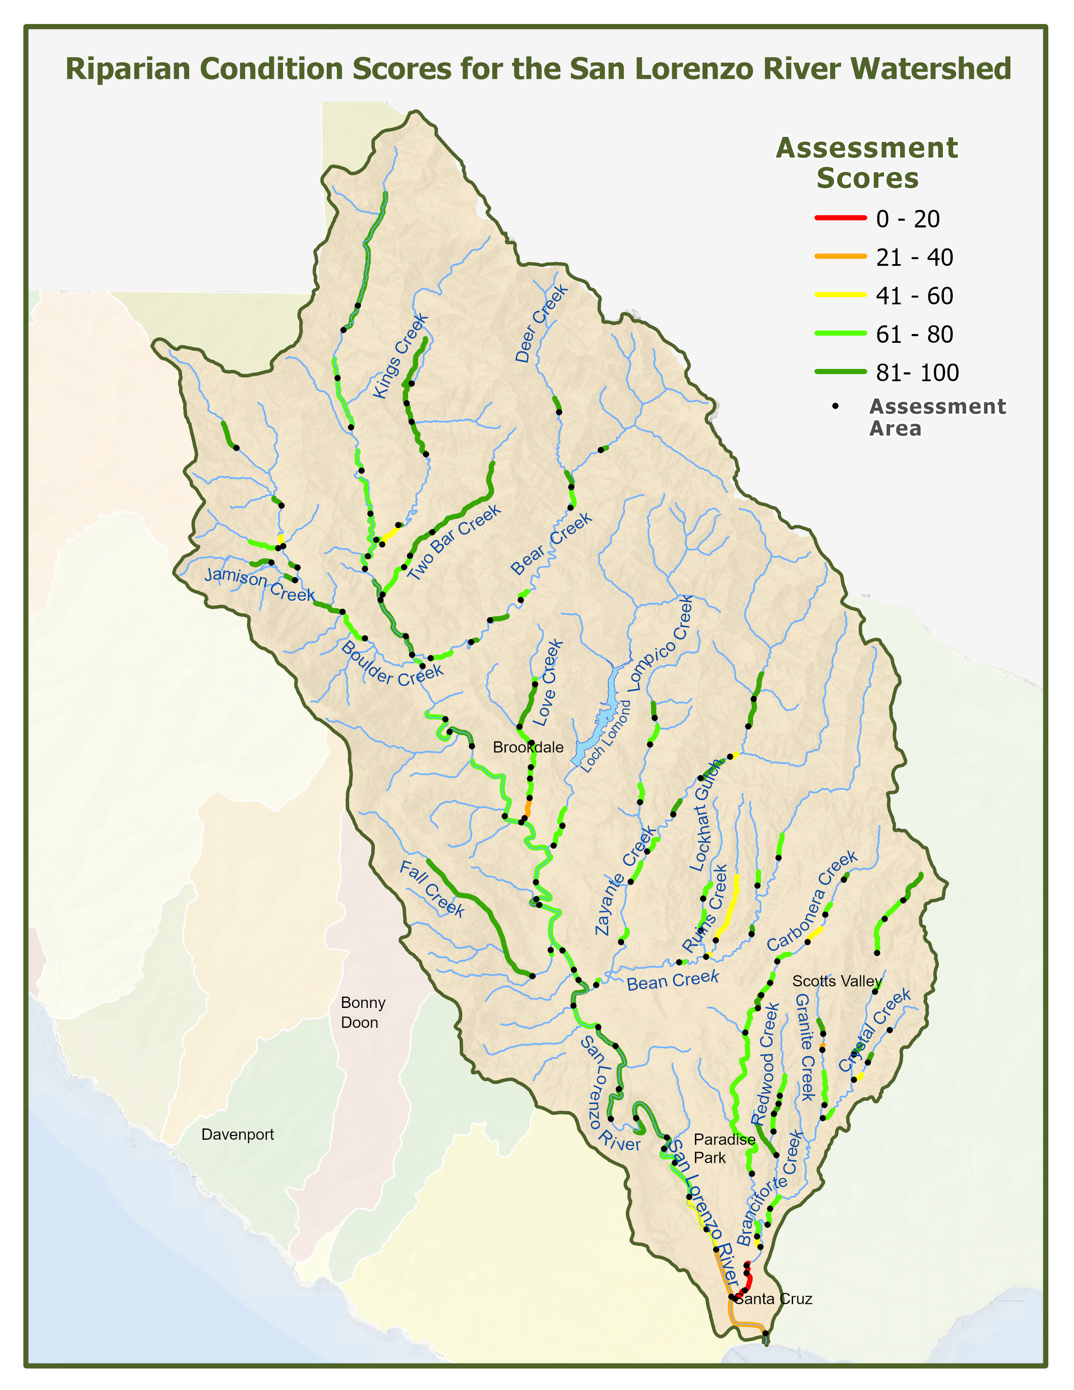
Figure 1. Map of the Assessment Areas in the San Lorenzo Watershed. This map shows each assessment site as a black dot and how far the Index Score was extended upstream. Index scores 0-20 shown as red; 21-40 orange; 61-80 light green and 81-100 dark green.
Analyzing Extent of Development:
For this analysis, an “Extent of Development”, or level of development within and adjacent to the AA, was assigned to each site to determine the level of correlation between development and RipRAM Index Score. Using aerial photographs taken from Google Earth, each assessment site was grouped into one of five Extent of Development categories depending on the percentage of the 100-year floodplain that had been developed. These categories are:
- Very Low: no development or building within the floodplain other than the access road;
- Low: 0-25% of the 100-year floodplain within the assessment area has some kind of development (such as buildings, crops and fields, or evidence of livestock operations);
- Medium: 26-50% of the 100-year floodplain within the assessment area has some kind of development;
- High: 51-75% of the 100-year floodplain within the assessment area has some kind of development;
- Very High: 76-100% of the 100-year floodplain within the assessment area has some kind of development

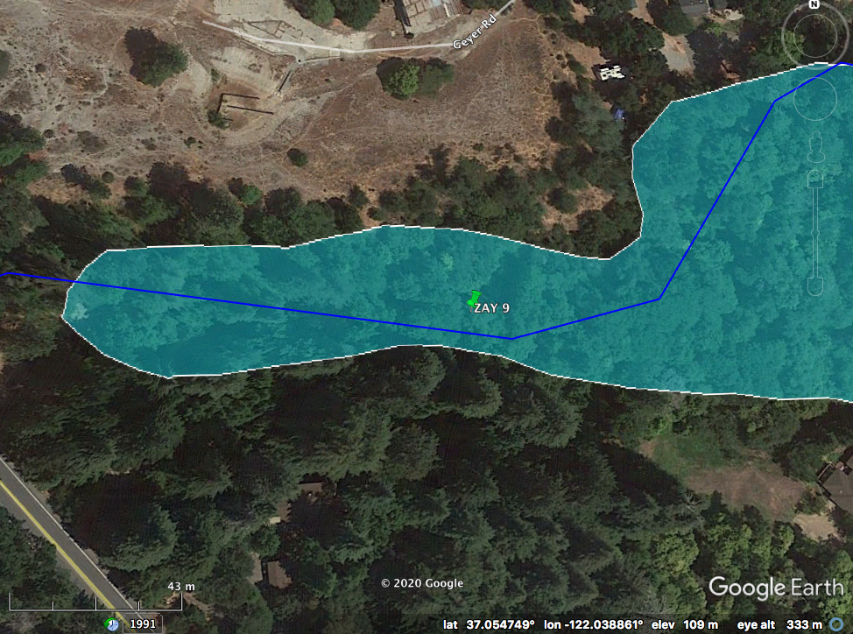

Figure 2A. FEMA Floodplain Aerial map for RipRAM assessment site Zayante-09 (green pin). The blue polygon represents the 100-year floodplain. This site was designated with an Extent of Development of “Medium”

Figure 2A is the aerial image used for the assessment site of Zayante-9 (ZAY-09), located on Bean Creek, roughly 1.5 miles upstream from Bean Creek’s confluence with Zayante Creek. Since roughly 50% of the area within the floodplain has been developed or cleared, this site received the ranking of Medium for Extent of Development. This site shows the average condition for the watershed and received the exact average Index Score (70) for the watershed.

Quality Assurance and Quality Control Review
As part of the analysis, data outliers were checked against raw data and field scoresheets and corrected. This study was conducted by five different teams over five years and this quality assurance/quality control improved the accuracy of the reported data and analysis. During the QA/QC process when some outliers were calculated using Extent of Development classifications, Google Earth’s Historical Imagery function was used to determine if the Extent of Development had changed since the initial assessment date. Second, raw data outliers were checked to see if any scores were misreported from the assessment to the data file. Scores for three sites were revised based on this review.

Results

Looking at scores across the entire watershed (Figure 1), a pattern emerges showing the highest scores within protected State Parks (Castle Rock in upper San Lorenzo; Fall Creek subunit along Fall Creek and Henry Cowell State Park along the lower mainstem) and upper tributary areas, such as Kings Creek, Two Bar and upper Zayante creeks. The majority of sites have Index Scores between 61-80 and include most of the mainstem and tributaries, including Branciforte and Zayante Creeks. Highly modified sites (channelized section of Love Creek in Ben Lomond) and San Lorenzo River within the Flood Control Project received scores between 21-40. The lowest scores were attributed to sites on the Branciforte Flood Control Channel within the City of Santa Cruz.
For the entire watershed, the highest score was 98, found on the San Lorenzo Mainstem in Henry Cowell State Park. The lowest Index Score was 2, found on Branciforte Creek at the confluence with the San Lorenzo River. Branciforte Creek was also the only subwatershed to achieve a score below 20. Of the 130 Assessment Sites, the average Index Score was 70. Figure 3 below shows the distribution of scores throughout the watershed.

Figure 3. Histogram of RipRAM Index Scores throughout the entire watershed.
When looking at each of the four groupings individually, Branciforte was the most variable, with a total of 33 assessment sites, a low score of 2, high score of 97, and an average of 66. Zayante had the fewest number of assessment sites at 21, was the least variable, and had a low score of 58, a high score of 95, and an average Index Score of 75. Zayante was also the only subwatershed to not have a score fall into the lowest two distributions of 0-20 and 21-40. The San Lorenzo Mainstem had a total of 37 assessment sites, a low score of 23, a high score of 98, and an average Index Score of 75. Finally, the San Lorenzo Tributaries had the highest number of total assessment sites at 39, with a low score of 38, a high score of 94, and the highest average score in the watershed at 78. These scores are depicted in both Figures 4 and 5.

Figure 1. Histogram of Index scores by subwatershed grouping.
The histogram in Figure 4 represents the breakdown of Index Scores within each grouping. The majority of sites, 66 of the 130 assessment sites or 51%, scored between 61-80. In the entire watershed, only 17 assessment sites out of 130 (13%) scored below 60.

Figure 5. Box plots of Index Score distribution across watershed groupings compared to the whole watershed.
Figure 5 was created using the same data as Figure 4 but includes the entire watershed as a comparison and shows the range, distribution, and mean of scores for each grouping. Branciforte had the highest variability, lowest average Index Score at 66, and lowest scores for the entire watershed since it included highly urbanized areas within the City of Santa Cruz. The Tributaries grouping had the highest mean of scores.

Table 2. Extent of Development. This table represents the Extent of Development that were recorded for each of the watershed groupings.
 | Very Low | Low | Medium | High | Very High | Number of Sites
Branciforte | 3 | 8 | 5 | 4 | 13 | 33
Zayante | 11 | 3 | 4 | 3 | 0 | 21
Mainstem | 5 | 10 | 10 | 4 | 8 | 37
Tributaries | 13 | 10 | 4 | 6 | 6 | 39
Number of Sites | 32 | 31 | 23 | 17 | 27 | 130

Since one of the primary goals of this study is to inform riparian conservation efforts, the analysis compared RipRAM scores and Extent of Development category, identified low and high scoring sites for each Extent of Development category, and then identified appropriate management actions which might enhance the riparian functions that are represented by the low metric scores. By discerning the primary stressors for each Extent of Development type and identifying restoration goals to reduce the effect of those stressors, RipRAM scores can be utilized to increase the overall fitness of assessment sites. For the 32 Very Low sites (25% of all assessments), the average score was 86, with a high of 98 and a low of 71. This low of 71 was the highest Low Index Score out of any other Extent of Development designation. For the 31 Low sites (24%), the average Index Score was 82 with a high of 95 and a low of 62. For the 23 Medium sites (18%), the average was 74, the high was 97, and the low was 56. For the 17 High sites (13%), the average was 70, the high was 89, and the low was 50. And finally, for the 27 Very High Extent of Development sites (21%), the average was 51 with a high of 91 and a low of 2. These distributions are shown in Figure 6 below.

Figure 6. Index Score distribution for the entire watershed by Extent of Development.

As expected, when looking at the entire watershed, as the level of development at each assessment site increases, the average Index Score decreases. When broken down into each grouping, only one category fails to follow this trend: In the “Tributaries” group, the Extent of Development “High” is 3 points higher on average than Medium. This is highlighted in red in the bottom row of Table 3 below.

Table 3. RipRAM scores (min, max and average) for each Extent of Development type by watershed group and the watershed as a whole.
Whole Watershed | Very Low | Low | Medium | High | Very High
Number of Sites | 32 | 31 | 23 | 17 | 27
Low | 71 | 62 | 56 | 50 | 2
High | 98 | 95 | 97 | 89 | 91
Average | 86 | 82 | 74 | 70 | 51
Branciforte | Very Low | Low | Medium | High | Very High
Number of Sites | 3 | 8 | 5 | 4 | 13
Low | 75 | 71 | 73 | 50 | 2
High | 89 | 95 | 97 | 78 | 91
Average | 81 | 81 | 81 | 70 | 45
Zayante | Very Low | Low | Medium | High | Very High
Number of Sites | 11 | 3 | 4 | 3 | 0
Low | 71 | 62 | 56 | 58 | NA
High | 95 | 77 | 70 | 68 | NA
Average | 84 | 71 | 65 | 62 | NA
Mainstem | Very Low | Low | Medium | High | Very High
Number of Sites | 5 | 10 | 10 | 4 | 8
Low | 90 | 78 | 63 | 57 | 23
High | 98 | 95 | 85 | 72 | 82
Average | 94 | 84 | 74 | 67 | 58
Tributaries | Very Low | Low | Medium | High | Very High
Number of Sites | 13 | 10 | 4 | 6 | 6
Low | 79 | 74 | 63 | 70 | 38
High | 94 | 94 | 84 | 89 | 70
Average | 86 | 85 | 74 | 77 | 54

Discussion

Assessment scores varied across the watershed, with an expected distribution of higher scores in protected and upper watershed areas, moderate values in rural residential areas, and lowest scores within highly modified or urbanized areas. The highest Index Score was 98, located on the Mainstem San Lorenzo in Henry Cowell State Park (SLRM 37). Other State Parks areas received high scores and validate the importance of protected areas in preserving riparian habitat. A conservation strategy should prioritize monitoring and maintenance of high-quality riparian areas.
Most sites (51%) received scores 61-80, indicating riparian habitat with a mix of conditions. In general, these moderate scores reflect both positive attributes, such as native tree canopy and natural channels, along with scores that are affected by development, invasive plants or bank modification. Moderate scoring sites were found throughout the watershed including much of the mainstem San Lorenzo River and tributaries, including Zayante, Bean, Branciforte, Newell, Love, Boulder and Bear creeks.
Low scores (0-40) occurred throughout the watershed and reflected either degraded riparian habitat quality, areas of dense residential use or within flood control projects. Low scores included sites on Kings Creek, Ruins Creek, Carbonera Creek, Crystal Creek. Lowest scores were associated with flood control projects within the City of Santa Cruz, including the Branciforte flood control channel and leveed San Lorenzo River. While these City of Santa Cruz sites were not originally intended to be included in the study, they demonstrate values for RipRAM Index scores for highly modified sites. City of Santa Cruz sites within flood control projects will not be considered for riparian restoration since they are managed under agreement with the Army Corps of Engineers.
The lowest Index Score in the entire data set was a 2, found in Branciforte Creek at the confluence with the San Lorenzo River (B40 31, 36.974414, -122.022086). The next three lowest scores in the watershed were the next three sites upstream (B40 32, 33, and 34). The highest Index Score was 98, located on the Mainstem San Lorenzo in Henry Cowell State Park (SLRM 37, 37.017385, -122.060362). These two scores represent both extremes of Extent of Development in the San Lorenzo River, since B40 31 is within an extremely leveed flood mitigation channel that backs up onto residential apartment complexes, and SLRM 37 is in an undeveloped state park. Many of the Very High Extent of Developments were reported in the most downstream areas of the mainstem San Lorenzo and its tributaries where development and anthropogenic alterations are higher, while most of the Very Low Extent of Developments were reported within state parks or the headwaters of the tributaries where the opposite is typically seen.
These two scores also represent both extremes of Extent of Development in the San Lorenzo River, since B40 31 is within an extremely leveed flood mitigation channel that backs up onto residential apartment complexes, and SLRM 37 is in an undeveloped state park. Many of the Very High Extent of Developments were reported in the most downstream areas of the mainstem San Lorenzo and its tributaries where development and anthropogenic alterations are higher, while most of the Very Low Extent of Developments were reported within state parks or the headwaters of the tributaries where the opposite is typically seen.
While this trend is certainly noticeable across the data set as a whole, as depicted by the graph above (Figure 6), three sites individually stand against that. In order to determine why these sites in particular were unusually low or high, the authors reviewed the raw data that showed what biotic and abiotic stressors were listed as the variables influencing the final Metric and Index Scores. First, in the Low Extent of Development Category (Figure 6-light blue outlier dot), Zayante 5 (37.071570°, -122.033320°) had the lowest score at 62 (average score was 82). When looking at the raw data, Metric 3 scored 0 and Metrics 2, 4, and 5 scored 50. Metrics 2 and 3 were negatively influenced by the presence of Silver Wattle (Acacia dealbata) as a codominant tree species and Himalayan Blackberry (Rubus armeniacus), an invasive herbaceous shrub species, covering over 50% of the assessment area. In the RipRAM Field Manual, a tree species is considered codominant if it represents 5% of all tree species found within the assessment area. Metric 4 was reduced because regeneration of native tree species was confined to the edge of the wetted channel with only mature trees above the high-water line and some evidence of anthropogenic interreference, such as cutting or trimming. Finally, Metric 5 scored 50 because there were reductions to vegetation width within the 100-year floodplain caused by human activity in 30% of the AA on the left bank and over 60% of the AA on the right bank. Adding all of these negative influences together is what caused the unexpectedly low score for this assessment site, where both Metrics 3 and 5 would have been expected to be higher based on the Extent of Development designation.
On the opposite end of the spectrum, Branciforte 30 (37.034298°, -121.987351°) was designated as Medium Extent of Development with an unusually high score of 97 (Figure 6-yellow outlier dot). When compared to all other Medium Extent of Developments in the data set (average score was 74), 12/23 (52%) of the assessment sites scored below 50 for Metric 3 and 16/23 (70%) scored below 50 for Metric 5. Branciforte 30 scored 100 for Metric 3 because of the presence of 6 codominant native tree species and no invasives present. It also scored 100 for Metric 5, indicating that riparian vegetation was expressed entirely throughout the AA to the edge of the 100-year floodplain with no evidence of anthropogenic development within the AA. The only Metric for Branciforte 30 that didn’t score 100 was Metric 6, resulting in the high score that was reported for this assessment site. Finally, Branciforte 28 (37.044559°, -122.016634°) was significantly higher than expected for the Very High Extent of Development category with an Index Score of 91 (average score was 51; not shown as an outlier in Figure 6). Of the 27 assessments for the Very High Extent of Development, 20 (74%) were below 50 for Metric 3, 18/27 (67%) were below 50 for Metric 4, 24/27 (89%) were below for Metric 5, and 16/27 (59%) were below 50 for Metric 6. Branciforte 28 had a 75 for Metric 3 where 2 codominant native tree species and 5 native shrub species boosted the score and only isolated populations of invasives present negatively impacted it. It also had a 75 for Metric 4, indicating natural regeneration of native tree species was occurring in at least 75% of the AA. For Metric 5, Branciforte 28 scored 87.5, illustrating almost full expression of riparian vegetation buffer throughout the left and right banks of the AA. And finally, for Metric 6, another 87.5 was caused by an almost completely natural condition in soil permeability throughout the assessment area.
By understanding what makes these three critical sites different from the expected outcomes allows for better recommendations to be made for restoration projects within the San Lorenzo watershed. When looking at each of the individual 8 Metrics across the entire data set, the two most influential are Metric 3 – Vegetation Cover Quality – and Metric 5 – Riparian Vegetation Width: 63/130 (48%) were below 50 for Metric 3 and 64/130 (49%) were below 50 for Metric 5. When reviewing the raw data to find the root cause of watershed-wide low scores for Metric 3, 40/130 sites (31%) had a minor reduction to the score from isolated patches of non-native plants species, 80 sites (62%) had significant reductions to the metric score for established communities of non-native plant species, and only 10 sites (7%) had no reduction for the presence of invasive plant species. Because 62% of all assessment sites in the watershed were significantly and negatively affected by riparian areas dominated by invasive plant communities, the removal of invasive plants is critical to increasing the fitness of the entire watershed. Invasive plant communities are a significant stressor reducing RipRAM Scores and riparian fitness. Restoration projects should focus first on the areas of the watershed represented by the 80 assessment sites that were significantly affected by invasives in Metric 3 and devise strategies for reducing or exterminating these communities of non-natives. Second, restoration projects should focus on planting multiple different tree and shrub species of different ages to increase the abundance of native vegetation that positively effects Metric 2, 3, 4, and 5. Finally, while Metric 5 was the most frequently negatively affected throughout the entire watershed, the primary reduction to these scores comes from the presence of man-made structures within the AA. It is unlikely that the City or County of Santa Cruz will be able to remove these structures in the near future, so the only significant way to increase the score for this Metric would be to plant aggressively throughout the 100-year flood plain between buildings and agricultural fields when applicable.
In the interests of being thorough, the authors also reviewed the top scoring sites to determine which Metrics had the highest influence on overall scores. Of the 21 sites that scored above 90, the only Extent of Development Category not represented was the High category (whose top score was an 89). When looking at this specific grouping of scores, one trend is consistent: all Metrics scored 75 or above. The only exception is Zayante 19, where Metric 3 scored 50. Zayante 19 was categorized as a Very Low Extent of Development but was marked down for the presence of isolated patches of invasive plants. Of these 21 sites, the lowest average scoring Metrics were Metric 6 (87) and Metric 5 (87). Actions that can be taken in higher scoring sites are increasing riparian buffer width with native riparian planting and maintaining soil permeability through reducing impervious surfaces within the riparian corridor, such as reducing unofficial hiking trails within the 100-year floodplain and maintaining native plant diversity. When looking at the assessment sites that scored well under the High and Very High Extent of Development, 4 sites scored above 80. For these 4 sites, almost all Metrics scored above 50, but Metric 5 scored the lowest on average with a total of 66. All other Metrics scored 75 or higher.
A comparison of RipRAM Index Scores and the Extent of Development ratings indicate that restoration should focus on active vegetation management, with a focus on removing invasive plants and planting native trees and shrubs. For each of the Extent of Development Categories, a restoration recommendation will be made based on which Metric scored the lowest on average. For the 32 Very Low sites, Metric 3 scored the lowest with an average of 73. Low had 31 sites and also scored the lowest on Metric 3 with an average of 70. Medium only had 23 sites, but scored lowest on Metric 5, with an average of 52. High had 17 sites but averaged 50 for both Metric 3 and 5. Finally, Very High had 27 sites, and averaged a 36 for Metric 3 and 37 for Metric 5. Removal of invasives and the planting of native tree and shrub species should be the primary focus moving forward in all Extent of Development categories because it is tied into almost every metric in one way or another. Doing this not only increases native plant abundance but has direct benefits for salmonids that will be significantly important under the rising threat of climate change.
One critical benefit of native revegetation is the shading of the creeks to reduce stream temperature, which improves metabolic efficiency of juvenile salmonids and impedes the spread of warm-water invasive fish species. A second effect from native riparian planting is the addition of future large and small woody debris that contributes to habitat for juveniles. A third beneficial effect is the addition of allochthonous invertebrate inputs from terrestrial habitats that feed on the native shrubs and act as a secondary food source for juveniles during high flows. Finally, the planting of native tree species will protect banks and armor shores to reduce erosion, something that is of great concern to property owners throughout the watershed that also directly benefits salmonids by maintaining clean spawning gravel for adults.
Riparian restoration can contribute to groundwater recharge if efforts include actions to increase soil permeability (Metric 6), which, in turn, will assist local agencies in meeting goals set by the California’s Sustainable Groundwater Act of 2014 (SGMA).
Areas without easy access at public bridges are underrepresented in the data set, including areas important for steelhead and coho salmon conservation such as Bean and Zayante Creek, and Bear Creek. The study also included sites within the City of Santa Cruz that will not be considered for riparian restoration since they are managed for flood control under agreements with the Army Corps of Engineers.
In 2020, the CZU Lightning Complex Fire affected about 9 assessment sites in the Boulder Creek subwatershed. These sites should be assessed again in 2021 to determine how fire impacted the baseline assessment scores and monitor their recovery process.

Conclusion
This study completed a baseline for current riparian habitat conditions in the San Lorenzo River Watershed. Using the recently developed RipRAM assessment method, teams assessed 130 sites throughout the watershed, including both tributary and mainstem sites. With the projection of scores upstream, the study provides data for a substantial portion of the watershed and many of the areas that provide habitat for steelhead and recovery areas for coho salmon.
Habitat quality (Metric 3) and Riparian Width (Metric 5) were strongly associated with lower RipRAM Index Scores. Assessment sites received lower habitat quality scores due to the presence of invasive plants within the riparian area. Sites received lower scores for width due to development within the 100-year floodplain. This association was further evaluated by looking at the correlation between Extent of Development and RipRAM scores that showed that, in general, scores decreased with higher levels of Extent of Development.
This baseline will be used to support the San Lorenzo Riparian Conservation Strategy to enhance riparian habitat for multiple benefits. In addition, these data and associated map can be used to educate resource managers, local agencies, and landowners about riparian habitats and restoration efforts.

Recommendations
- Re-assess sites that were impacted by the 2020 CZU Fire
- Determine if additional sites could be added for tributaries with data gaps, such as Bean and Zayante creeks.
- Encourage property owners with high quality riparian habitat to maintain quality through monitoring and removal of invasive plants.
- To improve riparian habitat conditions, develop programs and projects to remove invasive plants from riparian habitats and increase the width of the riparian corridor where feasible.

Acknowledgements

This analysis could not be conducted without the pioneering of RipRAM by the researchers at the Central Coast Wetlands Group and Kristen Kittleson, Fishery Resource Planner, County of Santa Cruz. Special recognition should also be given to the practitioners who conducted the 127 assessments since 2015. Funding for the development of RipRAM was provided by the USEPA, Region 9. Implementation of this study was funded by the Watersheds Stewards Program, California Conservation Corps and AmeriCorps. Financial support was also provided by the Central Coast Wetlands Group and Central Coast Regional Water Quality Control Board.

References

National Research Council, 2002. Riparian Areas: Functions and Strategies for Management.

“Riparian Corridor & Wetlands Protection.” Chapter 16.30 RIPARIAN CORRIDOR AND
WETLANDS PROTECTION, 05 Nov. 2019. Accessed 03 Mar. 2020.

“Riparian Rapid Assessment Method for California Version 1.6.” Central Coast Wetlands Group. 2019. Accessed 15 Mar. 2020.

“San Lorenzo River Riparian Conservation Program.” City of Santa Cruz Water Department et.
al. May 2018l Accessed 20 July 2020.

“Species Recovery & Riparian Health Programs.” RCD of Santa Cruz County. Accessed 02 Feb.
2020.

